Technical specification Atec 200
This section provides specifications for the ATEC multibeam echo sounder.

Performance
Swat coverage: | Up to 180°- typical 130 °
Number of beams: | 256
Operation frequency: | 100 - 800 kHz - nominal 200 kHz
Bandwith: | 0 - 40 kHz
Ping rate: | Up to 50 Hz
Maximum detected depth: | Up to 600 m - nominal 500m
Minimum detected depth: | 0.5 m
Range resolution: | < 10 mm @ minimum range
Resolution: | 2° across and along track

Weight and dimensions
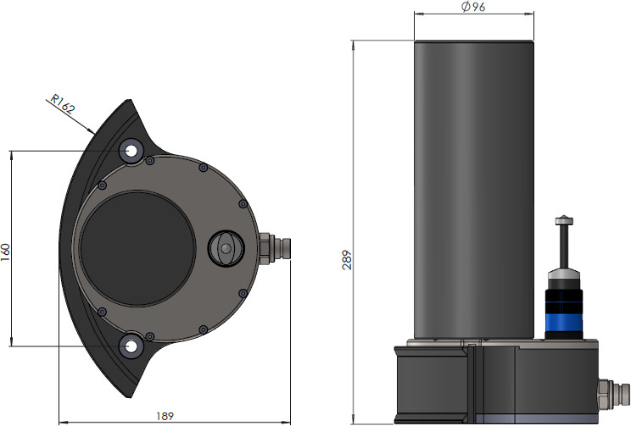
Weight: | 6.0 kilo
Length: | ~ 289 mm
Height: | 189 mm
Width: | 244 mm
Distance c/c mounting bolts: | 160 mm

Power
Voltage: | 20 - 28V DC
Power consumption: | Peak: 5A@28V  Nominal: 2A@28V
Standard cable length: | 8 m
Maximal cable length: | 50 m

Environment
Storage temperature: | -20 °C - + 60°C
Operating temperature: | -4 °C - + 40°C

Interface
Interface: | 100 Mb/s Ethernet

Integrated sound speed sensor
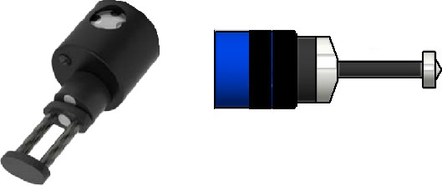

Sound speed: | 1400 - 1600 m/sec
Precision: | +/- 0.03 m/sec
Response time: | 47 µs
Pressure: | Down to 6000 m
Interface: | RS232 or RS485
Operating temperature: | -20 °C - + 60°C
Operating voltage: | (7.5 - 26V DC) uses the built-in power supply

